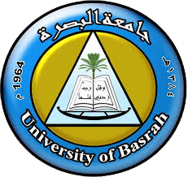 | Ministry of Higher Education and Scientific Research  Republic of Iraq |  |  | 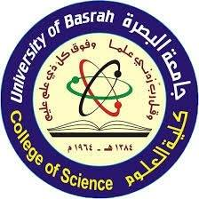
 | University: University Of Basrah
 | College: Science
 | Department : Pathological Analyses
Year : 2022-2023 |  |  | Semester : First

SYLLABUS: <biotechnology>
InstructoR: afrodet abdulrazaq saleh | Phone:009647803159713
Hours: 3 | Office: IraqiMinistryof Higher Education and Scientific Research
 | Email: afrodet.salih@uobasrah.edu.iq

Course Overview
This course is concerned with introducing the science of biotechnology, its origin, and its importance in the food, pharmaceutical and medical industries. Within the lectures of this course, we will focus extensively on the applications of biotechnology in medical journals and molecular techniques that use living organisms and cell cultures to produce drugs and therapeutic proteins in addition to genetic modification technologies and the production of genetically modified animals that are used as models to study diseases and drug efficacy

Goals and Objectives
- Introducing students to the concept of biotechnology
- Teaching students the types of biotechnology
- Teaching students the applications of biotechnology

Textbook and Readings
- “Pharmaceutical Biotechnology” by S P Vyas
- Chekol C, Gebreyohannes M. Application and Current Trends of Biotechnology: a Brief Review. Austin Journal of Biotechnology & Bioengineering, 2018;5(1):1-8.
- Mahroof S, Pant G, Rafeek R. Monoclonal antibodies: an emerging immunotherapy technology. European Journal of Biomedical, 2016;3(4): 134-143.
- Misra S. Human gene therapy: a brief overview of the genetic revolution. J Assoc Physicians India, 2013;61(2):127-33.

Course assessments
The course grade ( 3 points ) will be based on the following elements:
 | Points
Exams | 85
Participation | 10
Attendance | 5
Assignments | 100

COURSE DESCRIPTION AND ASSIGNMENT SCHEDULE
This NO. -credit hour course is 14 weeks long. You should invest NO. hours every week in this course.
WK | DATE | TOPIC | READING | ASSIGNMENT
1 |  | Introduction and Historical of biotechnology
2 |  | Types of biotechnology
3 |  | Applications of biotechnology
4 |  | comparison between molecular and biotechnology
5 |  |  |  | Assignment 1
6 |  | DNA cloning
7 |  | cell culture
8 |  | vaccines
9 |  | Recombinant of biotechnology : concept
10 |  |  |  | Assignment 2
11 |  | Methods of recombinant dna technology
12 |  | Requriments
13 |  | Genetic engineering
14 |  | purification of proteins
15 |  | Gene therapy

Is it possible to develop the curriculum <within the teaching authority 20%> to include vocabulary that serves sustainability
Developing life – long learning and education  Sustainable development  Development of general Health  Gender Equality  Efficiency of medicine and public health  Mechanisms for obtaining good health and well-being | 1- Yes, it is possible (point an appropriate aspect)the axes (point the axis)
 | 2- Suggest aspect that serves sustainability

